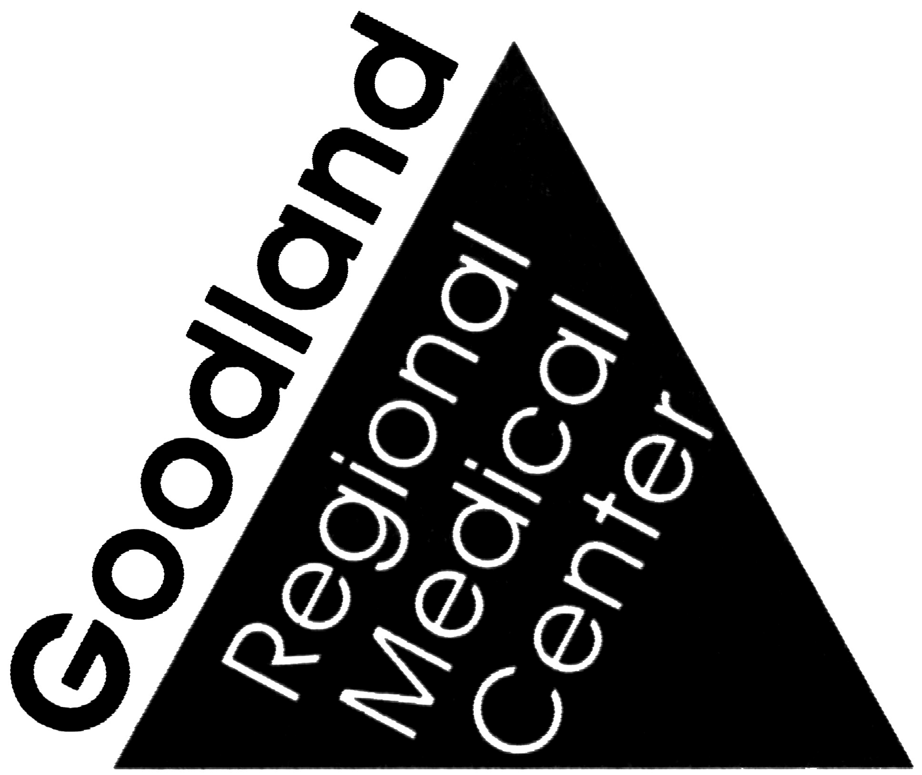
GOODLAND REGIONAL MEDICAL CENTER
JOB DESCRIPTION

JOB TITLE: Floor Technician / Housekeeper

RESPONSIBLE TO: Environmental Services Supervisor

JOB SUMMARY & SKILLS NECESSARY: Cleans all areas of the Hospital.
Performs routine cleaning and replenish supplies of patient rooms, nursing units, offices, clinic areas, waiting areas, lobbies, lounges, rest rooms, corridors, elevators and stairways in a clean, neat and sanitary manner.

FLOOR CARE TECHNICIAN: Floor care involving waxing, polishing, shampooing of carpets for evening work as established by Director of Environmental Services for designated members of the Environmental Service department. Requirement to work every other weekend. Work schedule is determined by work load. Possibility of rotating shifts.

ESSENTIAL JOB FUNCTIONS:

- Demonstrates behaviors consistent with organizational mission & goals.
- Demonstrates practices to keep all medical information confidential.
- Demonstrates behaviors that promote positive patient/staff relations.
- Comes to work as scheduled; arrives for work on time.
- Demonstrates proper safety practices in carrying out job duties.
- Appearance is appropriate to job duties; wears identification on duty.
- Demonstrates appropriate job competencies
- Complies with organizational policies in course of duties.
- Knowledge to utilize appropriate chemicals and supplies according to procedure.
- Use and maintain equipment properly.
- Transport trash and hazardous waste to appropriate disposal area.
- Request equipment and supplies for the purpose of maintaining inventory and ensuring availability of required items.
- Respond to emergency situations to resolving immediate safety/hazardous concerns.
- Perform assigned tasks in a professional manner.
15. Follow infection control practices.
16. Participate in performance improvement activities.
17. Ability to effectively communicate in English, both verbally and in writing.
18. Other duties as assigned/ required.
19. Floor care involving waxing, polishing, shampooing of carpets for evening work
as established by Director of Environmental Services for designated members of
the Environmental Service department (FLOOR CARE TECHNICIAN)
20. Requirement to work every other weekend. Work schedule is determined by work load. Possibility of rotating shifts.
21. Demonstrates ability to safely assist patients with transfer, lifting or rendering aid on the facility campus.

POSITION QUALIFICATIONS:

Minimum Education: High School graduate or equivalent

Minimum Experience: Three (3) months to six (6) related experience; or equivalent combination of education and experience. Will also train.

PHYSICAL DEMANDS:

Stand: C
Walk: C
Sit: O
Squat/Kneel: F
Bend: F

Lift/Carry: Push/Pull
0-10 pounds: F 10-25 pounds: F
10-20 pounds: F 25-50 pounds F
20-50 pounds: O 50-100 pounds O
50-100 pounds: N 100 + pounds: O
100 + pounds: N

(N) Non-Applicable; (O) Occasionally; (F) Frequently) (C) Constantly

**Reasonable accommodations may be made to enable individuals with disabilities to perform the position accountabilities without compromising patient care or departmental efficiency. However, should it de determined that the employee cannot meet the position accountabilities with or without accommodation, it is the right of GRMC to release the individual under Kansas “Employment at Will” doctrine**

Working conditions: The usual and customary methods of performing the job’s functions require the following physical demands: significant lifting, carrying, pushing, and/or pulling; some climbing and balancing; frequent stooping, kneeling, crouching, and/or crawling; and significant fine finger dexterity. The job is performed under minimal temperature variations and some hazardous conditions.

Professional Requirements: None Specified

I have received, read, and understand this job description for my position at GRMC:

Name/Signature:__________________________________ Date:_________________

Job Description Prepared by: ENVIRONMENTAL SERVICES DIRECTOR/HR

Signature/Title______________________________ Date:__________________

